SESSION 11
Central Limit Theorem (CLT)
Assignment Notes with Worked Demo
Topics covered: Why the Sampling Distribution Becomes Normal | Importance in Analytics | Real-World Examples | Demo: Simulating the CLT in Python with Repeated Samples

1. The Central Limit Theorem

1.1 Statement
The Central Limit Theorem states that if we take many random samples of size n from any population with mean μ and finite standard deviation σ, the distribution of the sample means (the sampling distribution of the mean) becomes approximately normal as n gets large, regardless of the shape of the population.
X̅ ~ Normal( mean = μ, standard deviation = σ / √n )
- Mean of the sample means: μ (the sample mean is an unbiased estimate of the population mean).
- Standard error: SE = σ / √n, which shrinks as the sample size grows.
- Standardised form: Z = (X̅ − μ) / (σ / √n) follows the standard normal distribution.

1.2 Conditions
- Samples are random and independent (for sampling without replacement, the sample is less than about 10% of the population).
- The population has a finite mean and standard deviation.
- The sample size is large enough. A common rule of thumb is n ≥ 30; a very skewed population may need more, while a population that is already normal works for any n.

2. Why the Sampling Distribution Becomes Normal
The result is mathematical, but the intuition is simple.
- Averaging cancels extremes. A sample mean combines many values. Unusually high values and unusually low values tend to offset each other, so sample means cluster around the true mean.
- Many small independent effects add up. A sample mean is a sum of n independent random contributions divided by n. Sums of many small independent effects produce the bell shape, whatever the shape of each individual effect.
- Skewness fades with n. The skewness of the sample mean falls roughly in proportion to 1/√n, so a skewed population gives an increasingly symmetric distribution of means.
- Spread shrinks with n. The standard error σ/√n decreases, so the bell gets narrower and the estimate more precise. Quadrupling n halves the standard error.
Key point: The CLT is about the distribution of the sample mean, not of the raw data. The raw data stay skewed; only the distribution of averages becomes normal.

3. Importance in Analytics
- Confidence intervals: we can write mean ± z × SE even when the data are not normal.
- Hypothesis testing: z-tests and t-tests rely on the sample mean being approximately normal.
- A/B testing: comparing average revenue or conversion between two versions of a website uses the normality of sample means.
- Quality control: control charts for averages (X-bar charts) rest on the CLT to set control limits.
- Planning sample size: because SE = σ/√n, we can calculate how large a sample is needed for a target margin of error.
- No need to know the population shape: analysts can use normal-based methods on messy, skewed business data such as sales, waiting times and claim amounts.

4. Real-World Examples
Context | Raw data (not normal) | Quantity that becomes normal
E-commerce | Order values: many small, few very large | Average order value of a sample of orders
Logistics | Delivery times: right-skewed | Average delivery time per sample of deliveries
Call centre | Call duration: skewed | Average handling time per sample of calls
Surveys | Each answer is Yes / No | Sample proportion of “Yes” answers
Manufacturing | Weights of individual items | Average weight of a sampled batch

Worked example: average order value
Problem: Order values of an online store are heavily skewed with mean μ = Rs. 500 and standard deviation σ = Rs. 500. A random sample of n = 100 orders is taken. What is the probability that the sample average is above Rs. 600?
SE = σ / √n = 500 / √100 = 50
Z = (600 − 500) / 50 = 2.00
P(X̅ > 600) = P(Z > 2.00) ≈ 0.0228 (about 2.3%)
Although individual orders are far from normal, the CLT lets us treat the average of 100 orders as normal and obtain this probability.

5. Demo: Simulating the CLT in Python with Repeated Samples

5.1 Objective
Show that the distribution of sample means becomes normal as the sample size grows, even when the population is strongly skewed.

5.2 Method
- Create a skewed population of 100,000 customer spend values (exponential distribution with mean about Rs. 500).
- For each sample size n = 1, 5, 30 and 100, draw 5,000 random samples and compute the mean of each.
- Plot the histogram of the 5,000 sample means for each n.
- Compare the mean, standard deviation and skewness of the sample means with the CLT predictions.

5.3 Python code
import numpy as np
import matplotlib.pyplot as plt
from scipy import stats

np.random.seed(42)

# Skewed population: customer spend (exponential, mean ~ 500)
pop = np.random.exponential(scale=500, size=100000)
mu, sigma = pop.mean(), pop.std()
print(mu, sigma, stats.skew(pop))

sample_sizes = [1, 5, 30, 100]
fig, axs = plt.subplots(1, 4, figsize=(13, 3.2))

for ax, n in zip(axs, sample_sizes):
# 5,000 repeated samples of size n -> 5,000 sample means
means = np.array([np.random.choice(pop, n).mean()
for _ in range(5000)])
print(n, means.mean(), means.std(),
sigma / np.sqrt(n), stats.skew(means))
ax.hist(means, bins=40, density=True)
ax.set_title(f'n = {n}')

plt.tight_layout()
plt.show()

5.4 Output: histograms of the sample means
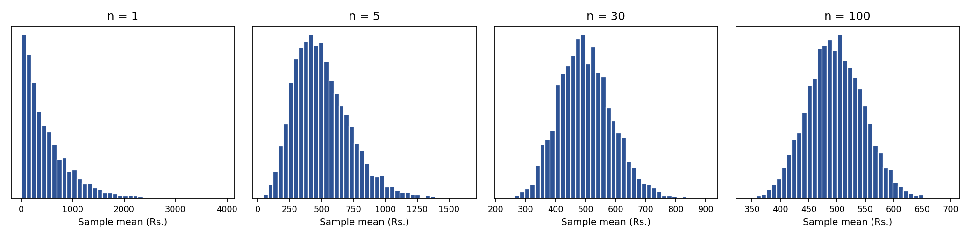
Figure 1: Distribution of 5,000 sample means for increasing sample size

5.5 Output: numerical results
Population: mean μ = 497.99, standard deviation σ = 496.48, skewness = 1.99 (strongly right-skewed).
Sample size n | Mean of sample means | SD of sample means | CLT prediction σ/√n | Skewness
1 | 501.19 | 489.86 | 496.48 | 1.86
5 | 505.64 | 221.47 | 222.04 | 0.85
30 | 500.30 | 90.66 | 90.65 | 0.39
100 | 497.55 | 49.67 | 49.65 | 0.14

5.6 Interpretation
- n = 1: the histogram looks just like the population, strongly skewed to the right.
- n = 5: still skewed, but the peak is moving away from zero and the tail is shorter.
- n = 30: the shape is close to a bell curve, with only slight skew remaining.
- n = 100: the distribution is almost perfectly symmetric and normal (skewness 0.14).
CLT checks: (1) the mean of the sample means stays close to μ ≈ 498 for every n; (2) the standard deviation of the sample means matches σ/√n (for example, 90.66 against 90.65 for n = 30); (3) the skewness falls toward 0 as n increases. ✔

5.7 Conclusion
Even though customer spend is strongly skewed, the average of repeated samples becomes approximately normal as n grows, centred on the true mean and with spread σ/√n. Because of this, analysts can build confidence intervals and run hypothesis tests on sample averages without needing the raw data to be normal.

6. Formula Cheat Sheet
Concept | Formula
Mean of sampling distribution | μ(X̅) = μ
Standard error of the mean | SE = σ / √n
Standardised sample mean | Z = (X̅ − μ) / (σ / √n)
Standard error of a proportion | SE = √[ p(1 − p) / n ]
Rule of thumb | n ≥ 30 for approximate normality

